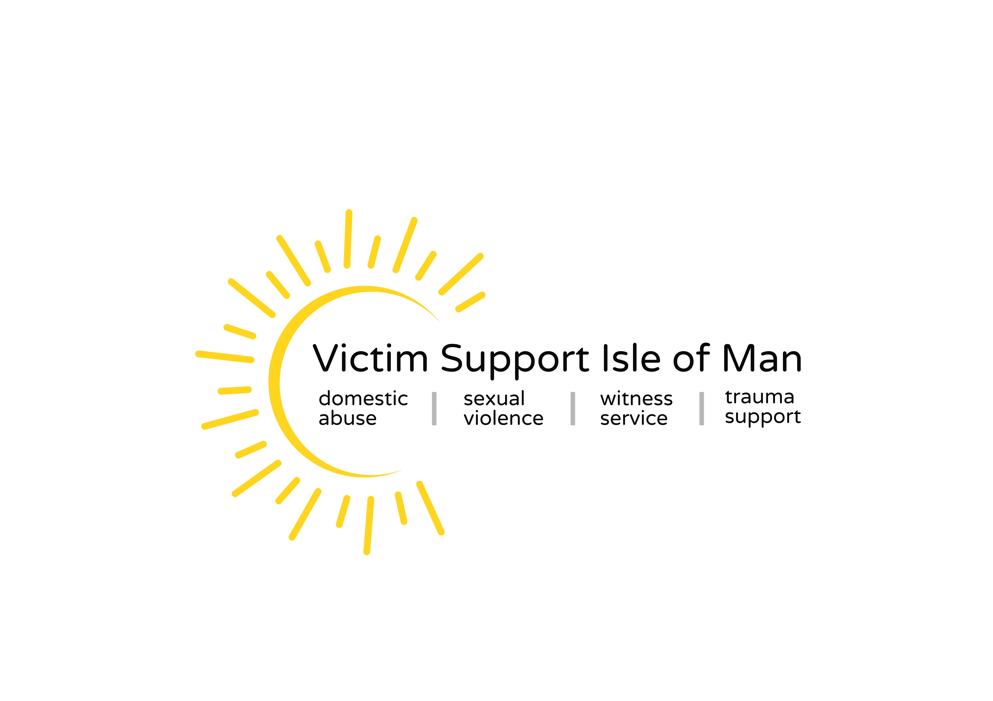
Job Description
Section 1 - Job Details
Job title | Caseworker
Reports to | CEO
Direct reports | No direct reports
Section 2 - Job Purpose
Ensuring the provision of individual structured, tailored support plans, based on a holistic assessment of impact and risk, within the framework of VS’s Service Model. You may make initial contact with victims of crime, explaining our services and assessing the impact of crime, or receive referrals from colleagues, in order to provide on-going support and case management.

To develop, deliver and monitor safety and support plans for those affected by crime, who accept ongoing support. Support will include providing resources, interventions, and information to all service users. In order to:
- support those affected by crime in understanding and asserting their rights and entitlements
- understand their journey through the criminal justice and legal systems including the Victims Code of Practice
- facilitate access to additional services
- establish healthy coping mechanisms
- provide practical support and information

Caseworkers will directly support service users, who may be affected by all types of crime. You may work within a specialist area, for example concentrating on one crime type, or a certain demographic of victims.

You will be responsible for elements of volunteer management. This may include the development and case management oversight of a cohort of volunteers who will contribute to the service, in line with VS’s policies and volunteering ethos and approach.

Section 3 - Main Responsibilities/activities

 | Responsibility/ activity
1 | Effectively manage a caseload of self-referrals or referred service users, delivering excellent services which support the commissioners and their service goals to victims. Where relevant to undertake initial proactive contact with victims, explaining VSIOM services and promoting the benefits of accessing support.
2 | Ensure each victim receives an individually appropriate tailored support and information service that fully meets their needs, keeping complex needs central to all processes and decisions.  This will be delivered face to face, via telephone, video-chat, text and/or email based on the preferences of the client. You may be required to facilitate or support group or peer support approaches.  Throughout a support relationship consistently revisiting impacts and outcomes or the service user, addressing emerging support needs within an agreed framework and Outcomes Star Tool.
3 | Undertake risk and needs assessments to address the specific needs of the client in line with VSIOM operating procedures. To follow relevant safeguarding policies and procedures, working with safeguarding leads and other agencies to ensure an integrated approach to address any safeguarding concerns.
4 | Provide information and advocacy to enable service users to navigate and understand the criminal justice process and ensure their rights are upheld in accordance with the Victims Code of Practice this could include criminal, legal and if relevant, civil remedies to service users.
5 | Identify barriers to individuals accessing our services and determine solutions. Working with existing multi-agency partners to which victims can be referred for ongoing and specialist support such as housing, social services and health provision. To also report on the effectiveness of relationships with partners with a view to improving services delivered by Victim Support Isle of Man.
6 | To work alongside a team of staff (and volunteers where applicable) to reflect the diverse community and the needs of the victims, including those with particular vulnerabilities, utilising national and local resources to deliver individual, bespoke services with respect, dignity and sensitivity.
7 | Develop and maintain effective working relationships and promote effective communication between staff and other stakeholders.
8 | Maintain accurate and confidential case records, complying with data protection and all other legislation connected to your work and sharing protocols where necessary. Contribute to monitoring information as required by Victim Support Isle of Man.
9 | Ensure that all clients are of aware of their rights under the Victim’s Code of Practice and the Witness Charter.
10 | To develop and manage a cohort of volunteers who will contribute to the service. In line with VS policy, with particular attention to volunteer accreditation, regular supervisions and annual review. Ensure volunteers work within existing safeguarding policies and procedures, data protection and information security, confidentiality policies, lone worker policies and other relevant policies
Section 4 – Dimension of the role

Resources | Responsible for the proper use and safekeeping of VSIOM assets  within scope of role.
Staff/Volunteers | Responsible for supporting a cohort of trained volunteers for the Witness Service and Fundraising
Budget | N/A

Section 5 – Key deliverables

 | Measures of success
1 | Provision of individual and appropriate high quality support to service users, supporting them in their journey through the criminal justice/legal systems and access additional support services.
2 | Delivery of an effective and excellent service to service users in keeping with the contract requirements and service delivery agreements.
3 | Achievements of annual performance review objectives.
Section 6 – Competencies

Competency | Level required (see below)
Builds customer value | 2
Drives performance | 1
Communicates effectively | 2
Embraces and drives change | 2
Grows diverse, high performing teams | 1
Level 1: Roles which make an individual contribution to the business, without line management or process responsibility e.g. frontline reactive service delivery roles, telephone-based support roles, administration roles
Level 2: Roles with or without line management responsibility are responsible for a casework/ face-to-face service provision/ internal/external process and or people (including volunteers) e.g. SDM/ SSDM/First Line Managers of People or Process.
Level 3: Roles with line management responsibility for people, normally front line / operational employees e.g. Area Manager/ Middle Management or National Lead/ professional roles with no direct line reports.
Level 4: Roles which deliver a strategy; lead people and / or own a process directly influence
senior leaders e.g. AD’s/Heads of Department.
Level 5: Roles in this area create strategy for the business e.g. CEO/SMT

Section 7 - Learning & Development requirements

Foundation (mandatory) | Required to complete all mandatory  foundation learning as per organisational policy
Introduction to Line Management  (mandatory) | N/A
Additional internal learning/courses | DA SV  Homicide Timeline  Safeguarding  Outcomes STAR
Other professional training (details of training or qualification should be added. It should be noted that such requirements are subject to funding availability so consideration must be  given to necessity to undertake the role) | IDVA
Section 8 - Person specification (qualifications, knowledge, experience, skills and attributes needed for the Job)
Essential criteria will be tested at application stage (A) and used to shortlist candidates for interview.

Requirement | Essential | Desirable | Tested*
Understanding of the impact of crime on victims such as anti-social behaviour, domestic abuse, sexual violence and hate crime. | √ |  | A/I
Effective verbal and written communication skills. | √ |  | A/I
Proven track record of successfully delivering services and working directly within a statutory, voluntary or multi agency setting(s). | √ |  | A/I
Using generic IT applications competently. | √ |  | I
Understanding and practical application of Equal opportunities and diversity and inclusivity. | √ |  | A/I
Ability to balance competing needs and priorities. | √ |  | A/I/P
Ability to work independently and as part of a team. | √ |  | A/I/P
Maintaining professional boundaries. | √ |  | A/I/P
Knowledge and understanding of the requirement for confidentiality and safe working practices, maintaining records in accordance with the Data Protection Act and other legal requirements. | √ |  | A/I
The ability to identify, develop and maintain partnerships with all relevant external organisations | √ |  | A/I/P
Experience of managing a caseload including complex case management |  | √ | A/I/T
Experience of outcome focussed working. | √ |  | I/P
Knowledge of risk and needs assessment framework. | √ |  | I/P
Role of statutory agencies including the criminal justice system and social care. |  | √ | I
Full driving licence, and access to a car which is insured for use at work | √ |  | I
*Tested – A (application), I (interview), T (test or Assessment),P (through performance reviews including probation, 1:1’s and PDR)

Section 9 – Additional Information and Requirements

Key Contacts/Relationships
Working with a number of agencies including (but not exclusively) Police, Probation, Isle of Man Courts, Attorney General Chambers, Social Services, Third Sector partners, Manx Care, working to meet the service and clients’ needs.

Physical or mental demands
Low physical demands, but high emotional/personal resilience required to manage casework demands.

Travel
The role is largely office-based but there may be a requirement to travel to attend appointments with clients and to attend meetings and training events including rare overnight stays

Unsocial hours
There may be an occasional need to work outside core hours to meet the demands of the role.

Confidentiality
Ensure that essential information of a sensitive and/or personal nature is not disclosed to, or discussed with, inappropriate persons and that all information is maintained in accordance with the GDPR and other related legislation/requirements.

Equality, diversity and inclusion
Ensure all duties are carried out in a manner which promotes VSIOM’s equality, diversity and inclusion policies.

Health & safety
Promote a health and safety culture, observe all health and safety rules and procedures and complete training courses, as required.

Safeguarding
VSIOM is committed to recruiting with care and to safeguarding and promoting the welfare of children, young people and vulnerable adults and expects all staff and volunteers to share this commitment. Background checks and Disclosed Barring Service checks will be required.

Digital skills
Competently utilise technology to perform the role including internet-based voice and video calls, Microsoft Office applications, case management system software and other bespoke VS software and applications.

Other Requirements
  - Undertake such other duties as required consistent with the duties of the post and the needs of the organisation which may include attending and assisting at fundraising events.
  - Handle any monies you may receive in line with cash handling policies and procedures
  - In accordance with health and safety requirements, monitor the day-to-day security, and health & safety of the workplace
  - Undertake administration and general office duties as required.
  - Provide support to the CEO and Office Manager for the organisation of the premises at 6 Albert Street, Douglas
  - To attend supervision sessions for client matters
  - To attend Board meetings when requested
  - Be of Good Character
  - Ensure own personal development through constructive use of supervision, training and the appraisal system

This job description serves to illustrate the type and scope of what is required for the above post and to provide an indication of the required level of responsibility. It is not a comprehensive or exclusive list and duties may be varied from time to time, they will not however change the general character of the job or the level of responsibility entailed.

Last updated December 2025

